Medication, Illness and First Aid Policy
COVID-19 (Please see section 14 of this policy)

Allens Croft and Shenley Fields Nursery Schools

Children have the ‘right’ to be healthy and have access to healthcare services. (United Nations Convention on the Rights of the Child, Article 24).

Our named First Aiders at Allens Croft Nursery School are: Laura O’Neil, Amanda Smith

Our named First Aiders at Shenley Fields Nursery School are: Louise Shepherd and Sallyanne Bromley

The vast majority of our staff teams hold a paediatric first aid qualification.

The Law
Schools’ ‘appropriate authorities’ (Governing Boards of Maintained Schools, Proprietors of Academies and Management Committees in Pupil Referral Units) have a duty under section 100 of the Children and Families Act 2014 to make arrangements to support pupils at school who have medical conditions. Appropriate authorities must also have regard to the Statutory Guidance, which should be read alongside this document.

In addition, the Equality Act 2010 (the Act) prohibits discrimination on the grounds of a protected characteristic such as disability, defined under section 6 of the Act, which may include some children with medical needs.
The Public Sector Equality Duty (PSED), as set out in section 149 of the Act, came into force on 5 April 2011 replacing the Disability Equality Duty and requiring public bodies to have due regard in the exercise of their functions to the need to:

- Eliminate unlawful discrimination, harassment and victimisation and other conduct prohibited by the Act.
- Advance equality of opportunity between people who share a protected characteristic and those who do not.
- Foster good relations between people who share a protected characteristic and those who do not.

There are a number of ways that the responsible bodies for schools must not discriminate against pupils or prospective pupils which are set out in section 85 of the Act. This will include all aspects of school life, i.e. it will also apply to activities outside delivery of the curriculum, such as school trips, school clubs, and activities. Schools must make reasonable adjustments for children with disabilities where they are likely to be at a substantial disadvantage compared with pupils who are not disabled; which may include making adjustments to their practices, procedures and school policies.

Some pupils with medical needs may also have special educational needs (SEN) and may have an Education, Health and Care plan (EHCP) which sets out the pupil’s health, social care and special educational requirements. For pupils with SEN, this guidance should also be read in conjunction with the Special Educational Needs and Disability (SEND) Code of Practice. Generally, if a pupil’s EHCP is followed, schools will be able to demonstrate that they have complied with the SEND Code of Practice and the duty under section 100 of the Children and Families Act 2014.

Under the Health and Safety at Work Act 1974, employers, including Appropriate Authorities, must have a Health and Safety policy which, for schools, should incorporate, or refer to, their policy for supporting children with medical needs. Schools may wish to base their own Health and Safety policy on the corporate Health and Safety Policy. Schools’ Health and Safety policy should explain the procedures for conducting appropriate risks assessments.

Safeguarding

Schools must ensure that policies, plans, procedures and systems are properly and effectively implemented to align with their wider safeguarding duties.

Your school nurse/specialist voluntary bodies/ professional associations are available for advice, support and training.

**IF IN DOUBT OR IN AN EMERGENCY ALWAYS SEEK MEDICAL ADVICE**

1.0
It is the exception rather than the rule for prescribed medicines to be brought into Allens Croft and/ or Shenley Fields Nursery Schools.

1.1
A request to administer prescribed medicines within our provisions will only be considered after all other options have been explored and will only be considered if the refusal of such medicine would prevent a child from accessing Allens Croft or Shenley Fields Nursery Schools on a long-term basis.

1.2
Parents/ Carers are encouraged to discuss with their doctor/consultant the administration of prescribed medication and whether or not the prescribed medication can be administered outside the hours during which the child attends.

1.3
No member of staff is required to administer medicine. Unless specified in a contract of employment, this is a voluntary action. A member of staff that agrees to do this must follow these guidelines.

2.0
Short-term Illness (requiring antibiotics)

Parents are encouraged to ask the GP to prescribe antibiotics in dosages which mean that the medicine can be administered outside of school hours, wherever possible. This will mean that most antibiotic medication will not need to be administered during school hours. For example, if the prescription states that twice daily doses should be given, these can be administered in the morning before school and in the evening after school, and if the prescription requires three doses a day these can often be given in the morning before school, immediately after school and at bedtime. Antibiotics should always be administered in accordance with the prescriber’s instructions. It should normally only be necessary to administer antibiotics in school if the dose needs to be given four times a day, in which case a dose is needed at lunchtime.

2.1
Medication will not be administered for short term illnesses.

2.2
Ideally, children that are being treated with antibiotics for short term illnesses should be kept away from School provisions until the course of treatment has been completed.

2.3
Children that have suffered with vomiting whilst in attendance at Allens Croft and/ or Shenley Fields Nursery Schools, or have done so beyond the setting, should not return until 48 hours have passed since the last bout of sickness in order to limit the spread of germs.

2.4
Ideally the child should be kept away from school for the first 3 days of medication as any contra-reaction is most likely to occur on the third day. We follow the latest guidance issued by the Health Protection Agency when making these decisions (cited above the changing areas in provisions).

2.5
Products containing liquid paracetamol, such as ‘Calpol’, will not be administered as they shroud symptoms of illness.

2.6
Parents / Carers must inform school if a child is taking any medicine.

3.0
Long-Term Medical Needs

3.1
‘It is important to have sufficient information about the medical condition of any child with long-term medical needs. If a child’s medical needs are inadequately supported this may have a significant impact on a child’s experiences and the way they function in or out of school or setting. The Special Educational Needs (SEN) Code of Practice 2001 advises that a medical diagnosis or a disability does not necessarily imply SEN. It is often helpful to have a written health care plan for such children involving the parents / carers and relevant health care professionals’ (DCSF March 2009). This can include:

- Details of a child’s condition
- Special requirements e.g. dietary needs, pre activity requirements
- Side-effects of the medicines
- What constitutes an emergency
- What action to take in an emergency
- Who to contact in an emergency
- What not to do in an emergency
- The role the staff can play

Emergency Medication

Schools’ policies and Individual Care Plans will explain their procedures for dispensing medication in an emergency. Anyone caring for children, including teachers and any other school staff in charge of children, have a common law duty to act like any reasonably prudent parent and ensure that children are safe and well cared for in school which will extend to taking action in an emergency, for example by calling emergency services or arranging for medicine to be administered. Schools should consider what information or training they need to provide to new or temporary staff to enable them to comply with this duty, particularly if there are children with specific needs.

Schools should make staff aware that, generally, the consequences of taking no action in an emergency are likely to be more serious than the consequences of trying to assist. Pupil’s’ emergency medication must be readily accessible in a location which staff and the individual pupil know about, because in an emergency, time is of the essence.

The most common types of emergency medication which schools may be asked to administer include:-

- Buccolam (midazolam), used to treat epilepsy.
- Adrenaline, under the brand names epipen, jext, emerade, used to treat anaphylaxis caused by an allergic reaction;
- Glucose or dextrose tablets which may be branded Hypostop, used to treat hypoglycaemia caused by diabetes; and
- Inhalers, used to treat asthma (usually the blue ‘reliever’ inhaler).

Schools can arrange for training for all staff on how to handle emergency situations which will be provided by Birmingham School Health Advisory Service Nurses or appropriate specialist nurses, and can include training for the school staff who have volunteered to administer emergency medication.

4.0
Administrating Medicines

4.1
No child should be given medicines without their parent’s / carer’s written consent. Any member of staff giving medicines should check:

- The child’s name
- Prescribed dose
- Expiry date
- Written instructions provided by the prescriber on the label or container

5.0
Record Keeping
Allens Croft and Shenley Fields Nursery Schools ensure that a ‘Record of Medicine Administered to an Individual Child’ form is completed and signed giving details of the date, time and dose of any medication administered in school. Parents should be informed on the same day and a record kept if, for any reason, medication that a child normally receives is not administered. Schools may wish to keep a copy of the parent’s Consent Form to Administer Medication and School Record of Medication Administered with the medication.

We have a record of individual pupil’s needs in their Care Plan, which may also form part of their Education, Health and Care Plan if one is in place. Schools should review Care Plans regularly, at least annually and whenever there are changes to the pupil’s condition or treatment. A new Care Plan will usually be required if a pupil moves schools.

Under the Data Protection Act 1998 documents which contain information about an individual’s physical or mental health are ‘sensitive personal data’, or ‘special category data’ under the General Data Protection Regulation (GDPR). Schools’ policies should contain a privacy notice which explains when and how that medical information about a pupil and their care plan, where one is in place, will be shared with relevant staff. Schools must never display care plans in a public place because of the sensitive information they contain, but it would be sensible for schools to make parents, and where appropriate the pupil, aware that this information will be shared and that it will be kept somewhere accessible in case of emergency.

Schools should retain documents connected to a pupils medical needs and the administration of medication until the child is 25 years old in accordance with Department for Health requirements regarding the retention of medical and health records. This will also mean that records are available if a child, on reaching 18 years old, decides to pursue a claim of negligence against the school. Records should be carefully reviewed by the school before they are destroyed at the end of the retention period.

5.1
Written records must be kept each time medicines are given.
Medicines should always be provided in the original container as dispensed by a pharmacist and include the prescriber’s instructions.

5.2
Whenever a child is given medicine, staff must use the appropriate record sheet. Each and every time medicine is given a record of the following must be kept to avoid error; either medicine being forgotten or administered more than once:

- Name of child
- Name of medicine
- Dose
- Method of administration
- Time/frequency of administration
- Any possible side effects
- Expiry date

6.0
Linked Information

6.1
- Emergency contact details, Doctor’s contact details, immunisations
- Infectious diseases (for a copy of infectious disease control in schools and day nurseries contact 0121 472 1311)
- Importance of hand washing
- Procedures for cleaning up bodily fluids – see mop chart in bathroom areas.
- Vulnerable children
- Exclusion periods for communicable diseases – see the latest guidelines

6.2
The record of administered medicines should be checked before giving medicine to a child to ensure it has not already been administered.

6.3
When medication is given it should be recorded immediately.

6.4
It is good practice to administer medicine in the presence of another member of staff. If this is not possible, follow the procedure carefully.

6.5
The parent/s of the child should sign the record of administered medicines to ensure clear communication about what was administered and when.

6.6
It remains the parent’s responsibility to ensure there is enough medicine to be administered by the school and that it is replaced as appropriate and is within the expiry date.

7.0
Storage
Allens Croft and Shenley Fields Nursery Schools store non-emergency medication safely and securely, preferably in a cool place which pupils cannot access by accident. Schools should conduct a risk assessment in relation to their storage facilities in order to minimise the potential for harm to occur, which will include seeking advice from local pharmacists or the school nurse on how best to store medication.

Items requiring refrigeration may be kept in a clearly labelled closed container in a standard refrigerator, although schools should consider how pupil’s confidentiality can be maintained if the fridge is also used for other purposes. Schools should monitor the temperature of the fridge each school day and it would be good practice to keep a written record of the temperature, time and date. Children should be able to access their medicines, particularly for self-medication, quickly and easily, but all storage facilities should be secure and in an area which cannot be accessed by children without the supervision of an adult.

All emergency medication must be stored in a safe location known to the child and relevant staff, which is easily accessible in case of emergency. If the safe location is locked, it is essential that the keys can be quickly and easily accessed.

Members of staff who require medication must ensure that it is safely stored and cannot be accessed by pupils.

7.1
Medicines are to be securely stored in a secure cupboard. Emergency medication will be kept in a safe place but not locked away to ensure speedy access. Emergency medication is to taken to the evacuation point by members of staff working in the area where it is stored or by the responsible person when the alarm sounds.

7.2
Medicines that require refrigeration will be stored in a clearly labelled, closed container in a refrigerator away from foodstuff, where possible.

8.0
Return and Disposal of Medication
Some medical conditions and medications require the use of sharp items (sharps), for example lancets for blood glucose monitoring, which carry the risk of accidents that could lead to infection with blood borne viruses, which are preventable with careful handling and disposal. It is the personal responsibility of the individual using the sharp to dispose of it safely i.e. the the member of school staff assisting the pupil;

- A suitably sized sharps bin must be brought to the point of use so that used sharps can be disposed of immediately;
- Sharps bins are available on prescription where needed and should be emptied when two thirds full. Children should not be carrying used sharps bins to and from school themselves therefore arrangements for disposal should be outlined in the child’s Care Plan.

8.1
Parents / Carers are responsible for the disposal of medicines. Medicines shall be returned to parents / carers when:

- the course of treatment has been completed
- they are past their expiry date (all medicines are required to be no more than 3 months old before the parent/carer is required to seek a repeat prescription)
- labels become detached or illegible
- instructions have changed
- a child leaves the setting or at the end of each term

8.2
If a parent/carer does not collect all medicines they are to be taken to the local pharmacy for safe disposal.

8.3
It remains the parent’s responsibility to ensure that medicines are returned to them by the setting if/ when required for administration outside school.

9.0
Refusing medicines

9.1
If a child refuses to take medicine, staff should not force them to do so, but should note this in the records. Parents will be informed immediately should their child refuse their medication.

10.0
Educational Visits / Activities Beyond the Setting
Allens Croft and Shenley Fields Nursery Schools fully consider what adjustments can reasonably be made to enable children with medical needs to participate safely and as fully as possible on school trips which, for best practice, will include a risk assessment. We may decide to include this information in a child’s care plan, but on an event by event basis may need to consult parents, pupils and a healthcare professional to ensure that pupils can participate safely.

A trained member of staff or parent should accompany the child on the off-site activity. The ‘Consent Form to Administer Medicine’ should include off-site visits.

Our federated schools make it clear that parents need to separately inform private wrap-around services about their children’s health needs.

10.1
Before children take part in activities beyond our building and grounds, a risk assessment is undertaken re: the possible administration of medicines and medical treatment.

11.0
First Aid
Allens Croft and Shenley Fields Nursery Schools ensure that First Aid boxes, identified by a white cross on a green background, are available in all rooms accessed by children and adults and contain adequate supplies for treating injuries that may occur based the nature of the potential hazards identified by a risk assessment. Schools’ should make themselves aware of the Health and Safety Executive’s minimum expected provision.

Only the expected First Aid supplies should be kept which should not contain creams, lotions or drugs, however seemingly mild, but may include saline or water sachets to irrigate wounds.
The location of First Aid boxes is identified by clear signage in all rooms being accessed by children and adults.

First aid boxes must display the following information:-

- The name of the person responsible for their upkeep;
- The nearest alternative First Aid box, in case further supplies are required;
- A list of the contents of the first aid box and instructions for replenishing arrangements;
- The location of the school’s accident book.

Authorised school personnel should maintained and restock First Aid Boxes promptly when necessary and the staff who are responsible for maintaining the First Aid Box should be aware of the procedure for re-ordering supplies.

9.1 Minimum Expected First Aid box contents:

QTY | Description | Checked
1 | General Advice Leaflet | Weekly
2 | Protective Face Shield | Weekly
4 | Individual Sterile Triangle Bandage | Weekly
4 | Individual Conforming Bandage 7.5cm x 4m | Weekly
4 | Individual Sterile Standard Wound Dressing 18cm x 18cm | Weekly
50+ | Assorted Plasters | Weekly
5 | Eye Wash | Weekly
25 | Sterile Moist Wipes | Weekly
2 | Sterile Eye Dressing | Weekly
yes | Safety Pins, Scissors, Tweezers | Weekly
5 | Rolls of Hypoallergenic Tape | Weekly
yes | 2 Pairs of Disposable Gloves | Weekly

11.1
The named persons responsible for ordering and maintaining first aid resources are named at the outset of this policy. We endeavour to check each first aid box weekly. These should contain a sufficient quantity of suitable first aid materials and nothing else i.e. the use of tablets, antiseptic solutions, eye drops, burn cream and any other similar medication or treatment is strictly forbidden.

11.2
Plasters are used as an effective way of sealing a cut or wound and as a source of comfort to children, unless we are informed by a parent that this is unsuitable for their child.

11.3
First aid resources are kept in each of the teaching areas. Staff are made aware of the location of these resources during their induction programme.
11.4
The vast majority of our staff in our schools hold a current paediatric full first aid qualification.

12.0
Emergencies:

As part of a general risk management processes Allens Croft and Shenley Fields will have arrangements in place for dealing with general emergency situations, for example staff know how to call the emergency services and who is responsible for carrying out emergency procedures. Care Plans will give details of how to deal with specific emergencies relating to a pupil’s medical needs, including when and what medication should be administered.

Allens Croft and Shenley Fields staff are advised ‘if in doubt an ambulance should always be called’ and staff will never be permitted take a child to hospital in their own car. If a parent is unable to accompany their child to hospital, a member of staff will always accompany a child taken to hospital by ambulance and will stay with the child until their parent arrives.

If a parent is not present then health professionals, and not school staff, will be responsible for decisions about the medical treatment that the child requires. Staff accompanying a child to hospital have basic medical information about the child, for example their Care Plan if one is in place and identifying data e.g. full name and date of birth and their parents’ contact details.

12.1
Staff should not drive a child to hospital in their own car. An ambulance should be called in such circumstances.

12.2
Children with particular requirements may need an ‘individual health care plan’. This plan should identify how to manage the child and who has responsibility in an emergency throughout the day (this may need to include a member of the ‘before school’ or ‘after school’ provision, for example).

13.0
When a child sustains a Head Injury:
13.1
a qualified first aider should be informed and make an assessment. Informing the child’s parents should be considered.

13.2
it must be recorded in one of the accident books. The parent/carer collecting the child must sign and retain the slip.

13.4
we will endeavour to provide him/her with a head injury sticker, where available.

13.5
his/her key person/s and the leader of the provision will be informed, wherever possible.

13.6
staff should communicate effectively a head injury to a child as part of a child’s transition from one team to another and pass on the relevant forms to ensure parents/ carers are informed or in case the child’s condition deteriorates.

13.7
which results in unconsciousness or any of the symptoms listed on the ‘head injury checklist’, or one which results in hospital treatment must be recorded on an accident sheet in the Reception Office and sent to Birmingham City Council (where the incident occurs within our Nursery School provision) or held for our records (if within Neighbourhood Nursery provision).

14. COVID 19 Guidance

Returning to school is vital for children’s education and for their wellbeing. Time out of school is detrimental for children’s cognitive and academic development, particularly for disadvantaged children. This impact can affect both current levels of learning and children’s future ability to learn therefore we need to ensure all pupils can return to school sooner rather than later.
14.1. Pupils who are shielding or self-isolating
We now know much more about coronavirus (COVID-19) and so in future, there will be far fewer children and young people advised to shield whenever community transmission rates are high. Therefore, the majority of pupils will be able to return to school. You should note however that:
- a small number of pupils will still be unable to attend in line with public health advice because they are self-isolating and have had symptoms or a positive test result themselves, or because they are a close contact of someone who has coronavirus (COVID-19)
- shielding advice for all adults and children was paused on 1 August 2020 which means that even the small number of pupils who will remain on the shielded patient list can also return to school, as can those who have family members who were shielding - read the current advice on shielding
- if rates of the disease rise in local areas, children (or family members) from that area, and that area only, may be advised to shield during the period where rates remain high and, therefore, they may be temporarily unable to attend
- pupils no longer required to shield but who generally remain under the care of a specialist health professional are likely to discuss their care with their health professional at their next planned clinical appointment - you can find more advice from the Royal College of Paediatrics and Child Health at COVID-19 - ‘shielding’ guidance for children and young people
14.2. Specialists in paediatric medicine have reviewed the latest evidence on the level of risk posed to children and young people from coronavirus (COVID-19). The latest evidence indicates that the risk of serious illness for most children and young people is low. In the future, we expect fewer children and young people will be included on the shielded patient list.
14.3. Patients can only be removed from the shielding patient list by their GP or specialist, following consultation with the child and their family, and other clinicians where appropriate. If a child or young person is removed from the shielded patient list in due course, they will no longer be advised to shield in the future if coronavirus (COVID-19) transmission increases. Discussion by a clinician with those previously advised that they were a clinically vulnerable child or young person but can now be removed from the shielded patient list, and with their families are ongoing. Since shielding advice has paused nationally, except in a very few areas where the implementation of local restrictions is ongoing, all previously affected children should be able to return to school except where individual clinical advice not to do so has been provided.
14.4. Where a pupil is unable to attend school because they are complying with clinical or public health advice, we expect schools to be able to immediately offer them access to remote education. Schools should monitor engagement with this activity as set out in the action for all schools and local authorities section
14.5. The risk to children themselves of becoming severely ill from coronavirus (COVID-19) is very low and there are negative health impacts of being out of school. We know that school is a vital point of contact for public health and safeguarding services that are critical to the wellbeing of children and families.
14.6 The public health advice in this guidance makes up a PHE-endorsed ‘system of controls’, building on the hierarchy of protective measures that have been in use throughout the coronavirus (COVID-19) pandemic. When implemented in line with a revised risk assessment, these measures create an inherently safer environment for children and staff where the risk of transmission of infection is substantially reduced.

15. Section 1: Public health advice to minimise coronavirus (COVID-19) risks (Guidance for re-opening of schools October 2020)
We are asking schools to prepare for all pupils to return full-time from the start of the autumn term, including those in school-based nurseries. Schools should not put in place rotas. We continue to ensure:
- a requirement that people who are ill stay at home
- robust hand and respiratory hygiene
- reasonable enhanced cleaning arrangements
- active engagement with NHS Test and Trace

15.3. Based on current evidence and the measures that schools are already putting in place, such as the system of controls and consistent bubbles, face coverings will not be necessary in the classroom even where social distancing is not possible. Face coverings would have a negative impact on teaching and their use in the classroom should be avoided.

15.4. Where necessary, wear appropriate personal protective equipment (PPE)
The majority of staff in education settings will not require PPE beyond what they would normally need for their work. PPE is only needed in a very small number of cases, including:
- where an individual child or young person becomes ill with coronavirus (COVID-19) symptoms while at schools, and only then if a distance of 2 metres cannot be maintained
- where a child or young person already has routine intimate care needs that involve the use of PPE, in which case the same PPE should continue to be used

Please refer to the full guidance for further information:

https://www.gov.uk/government/publications/actions-for-schools-during-the-coronavirus-outbreak/guidance-for-full-opening-schools

Date Policy Adopted:
Local Committee: 07.02.2023
Full Governing Body: 13.03.2023
Review Date: Spring Term 2024

Signed: ____________________________ Sue Sidaway
Chair of Local Committee

Signed: ____________________________ Sean Delaney
Chair of Governors

Signed: ____________________________ David Aldworth
Executive Head Teacher

Appendices

Good Practice Points for Asthma Care
People with asthma have airways which narrow as a reaction to various triggers. The narrowing or obstruction of the airways causes difficulty in breathing and can usually be alleviated with medication taken via an inhaler.

Schools can hold salbutamol inhalers for emergency use but if a child diagnosed with asthma may need to use the school’s emergency inhaler, this possibility should be explained in their Care Plan and schools should have asked for parent’s consent at the same time. For further information and guidance, please see Guidance on the use of emergency salbutamol inhalers in schools, Department for Health, March 2015.

Schools should also consider:

- Keeping a register of children in school diagnosed with asthma together with copies of their parental consent forms enabling them to take medication, i.e. inhalers;
- Preparing Care Plans for pupils whose asthma is so severe that it may result in a medical emergency;
- Where to keep inhalers, including during offsite visits, so that they are stored safely but are readily available for children who need them, which may mean encouraging pupils of year 5 and above to carry their own inhalers. Arrangements should be considered on a case by case basis. If the pupil is too young or immature to take responsibility for their inhaler, it should be stored in a readily accessible safe place.
- In special school all inhalers should be kept in classrooms, but accessible immediately, and should be administered by staff who have received training.
- Asking parents to supply schools with a spare inhaler and spacer device for pupils who carry their own inhalers to store safely at school in case the original inhaler is accidentally left at home or the pupil loses it. This inhaler should have an expiry date beyond the end of the school year and parents should be asked to replace it if it does not. Schools should dispose of out of date inhalers regularly, either by returning them to parents or to the pharmacist.
- How they will ensure that all inhalers are labelled with the following information:-
- Pharmacist’s original label;
- Child’s name and date of birth;
- Name and strength of medication;
- Dose;
- Dispensing date; and
- Expiry date.

- Labelling children’s spacer device, which is used with an inhaler often by younger children, and making arrangement with parents to ensure that it is sent home to be cleaned regularly, e.g. at the end of each term.
- Taking appropriate disciplinary action, in line with their school’s Behaviour and, if they have one, Managing Substance Related Incidents policies, if inhalers are misused by pupils or others. Inhalers are generally safe and, if a pupil took another pupil’s inhaler, it is unlikely that that pupil would be adversely affected; however medical advice should be sought.
- The arrangements for monitoring inhaler use, and how parents will be notified if their child is using the inhaler excessively
- How to ensure that staff running PE lessons and sports activities are aware that physical activity will benefit pupils with asthma, but that these pupils may need to use their inhaler 10 minutes before exertion. The inhaler MUST be available during PE and games. If pupils are unwell they should not participate.
- How they will ensure that pupils who have a particular trigger for their asthma, such as animal fur, glue, nuts etc. can avoid those substances
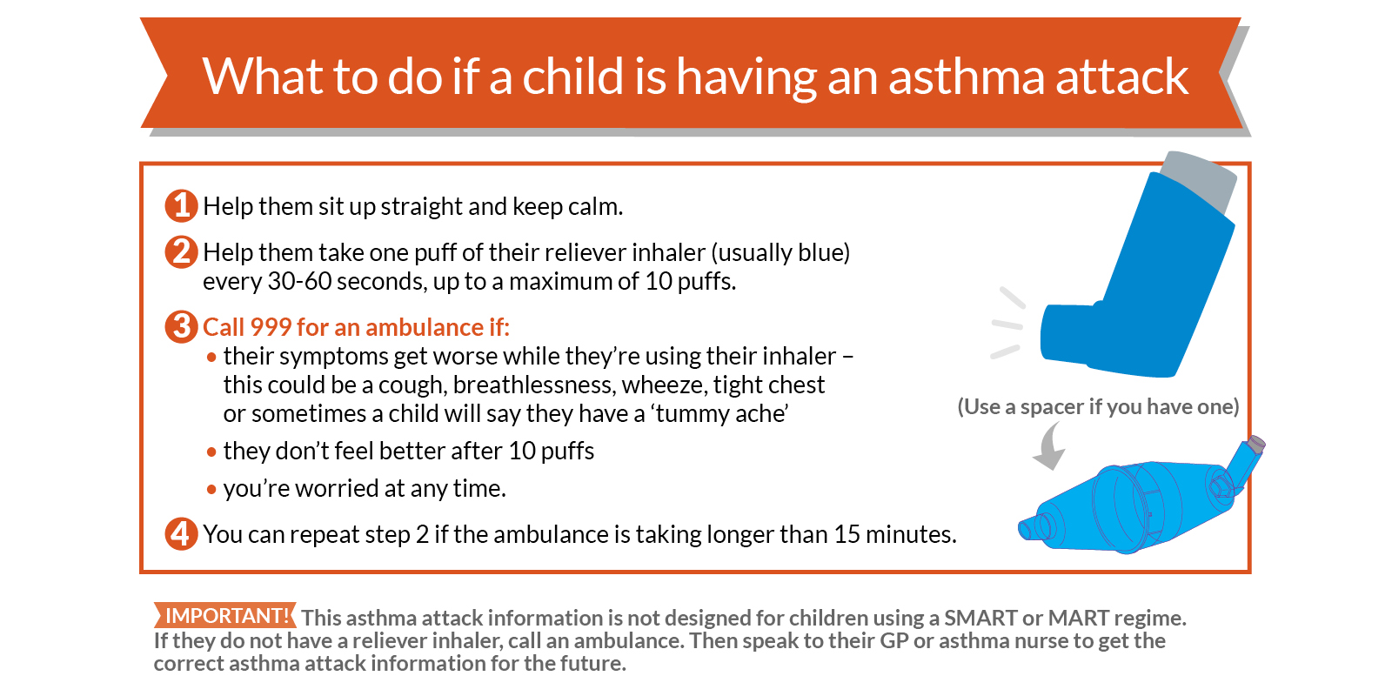
Further source of information:
Asthma UK
Tel: 0300 222 5800
Email: info@asthma.org.uk
https://www.asthma.org.uk/

Good Practice Points for the Administration of Auto Adrenaline Injectors

Anaphylaxis is an acute, severe allergic reaction requiring immediate medical attention. It usually occurs within seconds or minutes of exposure to the allergen, which may be a certain food or other substance, but may occur after a few hours.

Auto adrenaline injectors should only be administered by staff who have volunteered and been trained by the appropriate health professional. Schools should have obtained parental consent and prepared a Care Plan for the child on becoming aware that the child has been prescribed this medication.

An auto adrenaline injector (AAI) is a preloaded pen device, which contains a single measured dose of adrenaline for administration in cases of anaphylaxis. It is not possible to give too large a dose from one device used correctly in accordance with the child’s Care Plan, so even if it is given inadvertently it is unlikely to do any harm. However medical advice should be obtained as soon as possible after the medication is administered. Auto adrenaline injectors should only be used for the person for whom it is prescribed.

National guidance on AAI’s within school was released by the DfE in September 2017 and this should be considered as a supplement to this guidance. The DfE Guidance can be found at: https://www.gov.uk/government/publications/using-emergency-adrenaline-auto-injectors-in-schools

Schools should consider:

- Where to safely store the AAI, in the original box, at room temperature and protected from heat and light, so that it is readily available. If the Care Plan records that the pupil is competent then the AAI can be carried on their person
- What systems can be put in place to check, termly, the AAI expiry dates and discolouration of contents so that parents can be asked to dispose of and replace medication.
- Ensuring that all staff know that immediately after the AAI is administered, a 999 ambulance call must be made and parents notified. If two adults are present, the 999 call should be made at the same time as the administration of the AAI. The used AAI must be given to the ambulance personnel.
- The use of the AAI must be recorded on the School Record of Medication Administered, with time, date, and full signature of the person who administered it.
- Reminding parents that, if the AAI has been administered, they must renew it before the child returns to school.
- Ensuring that the pupil is accompanied by an adult, who has been trained to administer the AAI on off-site visits, and that the AAI is available and safely stored at all times during the visit.

Administering Epipen:

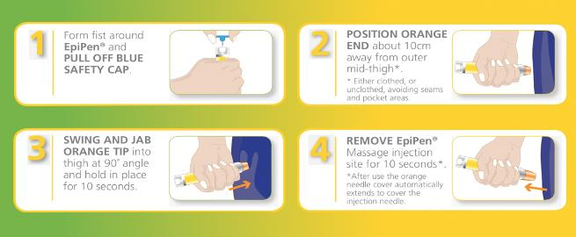

Administering Jext:
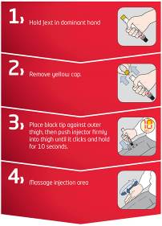
Administering Emerade:
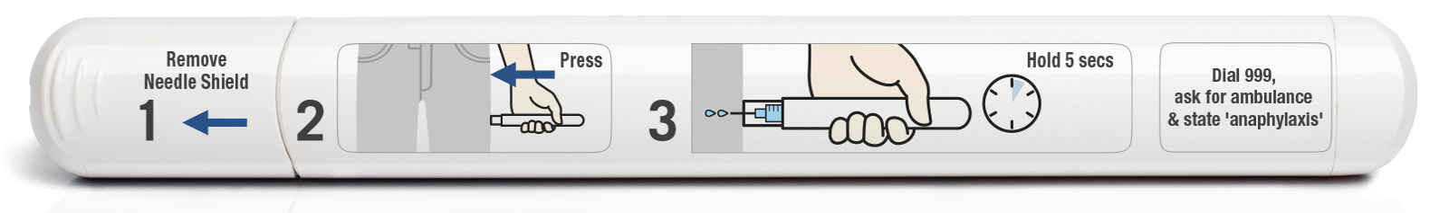
Further source of information
The Anaphylaxis Campaign
Helpline: 01252 542029
Website: https://www.anaphylaxis.org.uk
Email: info@anaphylaxis.org.uk

Good Practice Points for the Management of Diabetes
Diabetes is a condition where the person’s normal hormonal mechanisms do not control their blood sugar levels because the pancreas does not make any or enough insulin, because the insulin does not work properly, or both. There are two main types of diabetes:

Type 1 Diabetes develops when the pancreas is unable to make insulin. The majority of children and young people will have Type 1 diabetes and need to replace their missing insulin either through multiple injections or an insulin pump therapy.

Type 2 Diabetes is most common in adults, but the number of children with Type 2 diabetes is increasing, largely due to lifestyle issues and an increase in childhood obesity. It develops when the pancreas can still produce insulin but there is not enough, or it does not work properly.

Treating Diabetes
Children with Type 1 diabetes manage their condition by the following:-
- Regular monitoring of their blood glucose levels
- Insulin injections or use of insulin pump
- Eating a healthy diet
- Exercise

The aim of treatment is to keep the blood glucose levels within normal limits. Blood glucose levels need to be monitored several times a day and a pupil may need to do this at least once while at school.

Insulin therapy
Children who have Type 1 diabetes may be prescribed a fixed dose of insulin; other children may need to adjust their insulin dose according to their blood glucose readings, food intake, and activity levels. Children may use a pen-like device to inject insulin several times a day; others may receive continuous insulin through a pump.

Insulin pens
The insulin pen should be kept at room temperature but any spare insulin should be kept in the fridge. Once opened it should be dated and discarded after 1 month. Parents should ensure enough insulin is available at school and on school trips at all times.
Older pupils will probably be able to independently administer their insulin; however, younger pupils may need supervision or adult assistance. The pupil’s individual Care Plan will provide details regarding their insulin requirements.

Insulin pumps
Insulin pumps are usually worn all the time but can be disconnected for periods during PE or swimming etc. The pumps can be discretely worn attached to a belt or in a pouch. They continually deliver insulin and many pumps can calculate how much insulin needs to be delivered when programmed with the pupil’s blood glucose and food intake. Some pupils may be able to manage their pump independently, while others may require supervision or assistance. The child’s individual Health Care Plan should provide details regarding their insulin therapy requirements.

Medication for Type 2 Diabetes
Although Type 2 Diabetes is mainly treated with lifestyle changes e.g. healthy diet, losing weight, increased exercise, tablets or insulin may be required to achieve normal blood glucose levels.

Administration of Insulin injections
If a child requires insulin injections during the day, individual guidance/training will be provided to appropriate school staff by specialist hospital paediatric diabetic nurses, as treatment is individually tailored. A Care Plan should be prepared.

Best Practice Points for Managing Hypoglycaemia (hypo or low blood sugar) in Children Who Have Diabetes
Schools should offer all staff diabetes awareness training which will be provided by the paediatric diabetic nurses, if a child in the school has diabetes. Training should include how to prevent the occurrence of hypoglycaemia which occurs when the blood-sugar level falls. Staff who volunteer can also be trained in administering treatment for hypoglycaemic episodes.
Symptoms of diabetes can vary from person to person, therefore it will always be necessary for schools to prepare a Care Plan for children who have the condition and obtain parental consent to administer treatment. Often, this will be done when the nurse attends the staff training session if the parent is also able to attend to give their views

To prevent a hypo
- Children must be allowed to eat regularly during the day. This may include eating snacks during class time or prior to exercise. Meals should not be unduly delayed due to extracurricular activities at lunchtimes, or detention sessions;
- Offsite activities e.g. visits, overnight stays, will require additional planning and liaison with parent; and
- Schools should ask parents to ensure that they provide the school with sufficient, in-date, quantities of the treatment that their child may require.

To treat a hypo
- Staff should be familiar with pupil’s individual symptoms of a “hypo” so that steps to treat the pupil can be taken at the earliest possible stage. Symptoms may include confrontational behaviour, inability to follow instructions, sweating, pale skin, confusion, and slurred speech;
- If a meal or snack is missed, or after strenuous activity, or sometimes even for no apparent reason, the child may experience a “hypo”. Treatment might be different for each child, and will be set out in their Care Plan, but will usually be either dextrose tablets, or sugary drink, or Glucogel/ Hypostop (dextrose gel) which should be readily available, not locked away and may be carried by the pupil. Expiry dates must be checked each term by the parent/carer.
- Glucogel/ Hypostop is used by squeezing it into the side of the mouth and rubbing it into the gums, where it will be absorbed by the bloodstream.
- Once the child has started to recover a slower acting starchy food such as biscuits and milk should be given.
- If the child is or becomes very drowsy, unconscious, or fitting, a 999 call must be made and the child put in the recovery position. Due to the risk of choking the caregiver should not attempt to give the child an oral treatment, i.e. a drink, tablets or food.
- Parents should be notified that their child has experienced a hypo, informed of the treatment provided and asked to provide new stocks of medication.

Once the child has recovered the School Record of Medication Administered should be completed

Best Practice Guidance for Blood Glucose Monitoring for Children
The Care Plan will explain how frequently the pupil needs to check their blood glucose levels and will set out the method that should be used.
It is recommended that all staff use a fully disposable Unistik 3 Comfort Lancets device if they are undertaking patient blood glucose testing on a pupil. This is a single use device and the lancet remains covered once it has been used.
If a child has an insulin pump, individual arrangements will be made with a specialist nurse and parents to ensure school staff are fully trained in the management and use of the pump.
For children who self-test the use of Unistiks is not necessary and he/she will be taught to use a finger pricker device in which a disposable lancet will be inserted. This device can be purchased at a local chemist or in some cases may be provided by the Paediatric Diabetes Specialist nurse. The disposable lancet can be ordered on prescription via the pupil’s GP.
Whenever possible, staff will encourage pupils to undertake their own finger prick blood glucose testing and management of their diabetes, encouraging good hand hygiene. However, in exceptional circumstances such as a pupil having a hypoglycaemic attack, it may be necessary for a member of staff to undertake the test.

How to use the Unistik lancet:

- Prior to the test wash hands
- Encourage pupil to wash their hands wherever possible
- Ensure all equipment is together on a tray including a small sharps box
- Where possible explain the procedure to the pupil
- Apply gloves before testing
- Use a meter which has a low risk for contamination then blood is applied to the strip such as an optium exceed or one touch ultra
- Ensure meter is coded correctly for the strips in use and that the strips are in date.
- Place the strip into the meter
- Prick the side of the finger using a Unistik comfort 3
- Apply blood to the test strip according to the manufacturer’s instructions
- Once the test is completed put the used test strip and lancet directly into the sharps box
- Return the tray to a safe area/room
- Wash hands following the removal of gloves avoiding any possible contact with blood; use alcohol rub
- Record the blood glucose reading in the pupil’s care plan/diary
- Parents are responsible for supplying all necessary equipment and medication
- Provision and disposal of a sharps box should be discussed individually with the Paediatric Diabetes Specialist Nurse

Further notes:
The Care Plan will document what action to take if the blood glucose result is higher or lower than expected.

Further sources of information:
Diabetes UK
Tel: 020 7424 1000
Email: info@diabetes.org.uk
Website: https://www.diabetes.org.uk/

Good Practice Points for Managing Eczema
Eczema (also known as dermatitis) is a non-contagious dry skin condition which affects people of all ages, including one in five children in the UK. It is a highly individual condition which varies from person to person and comes in many different forms.
In mild cases of eczema, the skin is dry, scaly, red, and itchy but in more severe cases the child’s skin may experience be weeping, crusting, and bleeding which can be exacerbated by constant scratching causing the skin to split and bleed and leaving it open to infection. In severe cases, it may be helpful and reassuring for all concerned if a Care Plan is completed. . If whole body or significant creaming is required, factors that will need to be taken into account might include:

- Who will do the creaming? (Including taking into account how much the child can do for him/herself depending on age, maturity etc., Permission needed from parents)
- How often does this need to happen? (How can this be planned around curriculum time etc.?)
- Where will the creaming take place? (Considering the need to ensure both privacy and safeguarding of the pupil and the safety of staff.)
- What medication and/or equipment will the parents provide and what may school need to provide (e.g. gloves etc.)?
These details would all need to be provided on the pupil’s care plan.

Atopic eczema is the most common form. We still do not know exactly why atopic eczema develops in some people. Research shows a combination of factors play a part including genetics (hereditary) and the environment. Atopic eczema can flare up and then calm down for a time, but the skin tends to remain dry and itchy between flare ups. The skin is dry and reddened and may be very itchy, scaly and cracked. The itchiness of eczema can be unbearable, leading to sleep loss, frustration, poor concentration, stress, and depression.

There is currently no cure for eczema but maintaining a good skin care routine and learning what triggers a pupil’s eczema can help maintain the condition successfully, although there will be times when the trigger is not clear. Keeping skin moisturised using emollients (medical moisturisers) is key to managing all types of eczema, with topical steroids commonly used to bring flare ups under control.
Good practice point for epilepsy
Epilepsy is a neurological condition that causes recurrent seizures. This is caused by abnormal electrical activity in the brain. Seizures can happen anytime anywhere. 60% of people with epilepsy there is no known reason for them to have developed epilepsy. The other 40% there is an underlying cause or brain trauma. About 1 in 133 people suffer from epilepsy.
Epilepsy is diagnosed through a good medical history and an eye witness account of the seizure. When it is suspected that a child has epilepsy the child is sent for tests such as EEG’s and MRI to help support the diagnosis and to look for any structural abnormalities in the brain. There is a big problem with misdiagnosis, as some things that look like epilepsy are not epilepsy such as migraine and fainting.

There are two main types of seizures: focal and generalised.

- Generalized seizure is where the whole of the brain is affected and the electrical activity is coming from all over. These seizures are when the muscles relax and the person falls to the floor, they can become stiff and have generalized jerking of all four limbs. These are also the absence types of epilepsy.
- Focal seizures are when the electrical activity is localized to one part of the brain, these seizures can present with twitching in their face, hands, arms and legs. They can feel strong emotions, make unusual noises and have unusual behavior such as lip smacking, head turning to one side.
When you suspect a child to have a seizure, make sure you try and time the seizure, record what happened before, during and afterwards. If you have permission from parents a video is very helpful to make a diagnosis.

General first aid advice

- Managing a Tonic Clonic Seizure
If a child has a generalized tonic clonic seizure (jerking or all four limbs) it is important to stay as calm as possible. Reassure the other children in the classroom. Ensure that the child having the seizure cannot harm themselves

- Check safety of the area
- Move any potential dangerous object which the child could hurt themselves on
- Cushion head with something soft – such as a small jumper (especially if on concrete to avoid injury)
- Stay with the child throughout the seizure
- After the seizure is over put into recovery position until completely recovered
- Check the child for injury and maintain privacy and dignity throughout
DO NOT
- Restrain the child
- Do not move the child unless they are in direct danger
- Put anything in their mouth
- Do not give any food or drink

When to call for an AMBULANCE
- If the seizure is going on for longer than 5 minutes
- If it is the child’s first seizure
- If the child is injured
- If you are concerned at any point

REMEMBER
- Keep a record of the seizure
- Time the seizure
- Description of the event if possible - how it started, what happened, how it finished
- Did anything happen before the seizure? I.e. bump to the head, argument, sleepy, do they have a fever.
- What happened during? i.e. were they stiff, floppy, jerking, eyes rolled, head turned etc.- were they incontinent
- What happened after? I.e. how long it took to recover, were they sleepy after, did they go back to normal and do they remember it.

Epilepsy can be controlled with regular medications, emergency medications, Ketogenic diet, surgery and VNS. The medications that we use to control epilepsy are strong and important to take regularly. When a child is prescribed an anti-epileptic medication, they are usually given a plan with how and when to take the medication. Usually they only take the medication twice a day however, there are some children who need a third dose in the day time. If the child was to vomit after the administration of the medication, unless it was a tablet and you can see it, we would advise not to repeat the dose as you are not sure how much has been absorbed.

If a dose is missed, a catch up dose may be given within 4 hours of the designated time. After the 4 hours, do not give the dose and carry on with the next dose. If a child was to miss a dose of medication, be aware that they may have more seizures as a result.

Epilepsy can have a significant impact on a child’s achievement; they can experience problems with the visual/verbal learning process, reading, writing, speech language, numeracy, memory, psychosocial problems, concentration and behavior. We can help improve this through group work, providing written information as a prompt, making sure that the student has not missed anything, encourage note taking, cue cards, highlighting important information, rhymes, repetition and revision.

Every child with a diagnosis of epilepsy should have a health care plan in school with details on how to manage that child’s seizure. Children with emergency medication also need an up-to-date care plan with details of when to give the medication. Most of the time the child will be prescribed Buccolam (midazolam), however if the child cannot take this, they will be prescribed a rectal emergency medication.

Guidelines for the administration of Bucolic (midazolam)
Bucolic (midazolam) is an emergency treatment for epilepsy, for prolonged convulsions and clusters of seizure activity. It is administered via the mouth in the Bucolic cavity (between the gum and the cheek).

Bucolic (midazolam) can only be administered by a member of the school staff, ideally someone who spends the most time with the student, who has been assessed and has been signed to say they have received the training and know what to do. Training of the designated staff will be provided by the school nurse and a record of the training undertaken will be kept by the head teacher for the schools records. Training must be updated annually. The training must be child specific, general Bucolic (midazolam) training can be done but each child who requires it must have their care plan reviewed and understood by the staff members who would be administering the Bucolic (midazolam).

Bucolic (midazolam) care plans should reflect the specific requirements of each case and further advice should be sought from the specialist nurse/consultant/GP

- Buccolam (midazolam) can only be administered in accordance with an up-to-date written care plan with medical and parental input. If the dose changes it is the responsibility of the parent to have the care plan updates. Old care plans should be filed in the pupils records.
- The Buccolam (midazolam) care plan should be renewed yearly. The school nurse will check with the parent/ carer that the dose remains the same
- The care plan must be available each time the Buccolam (midazolam) is administered: if practical to be kept with the Buccolam (midazolam)
- Buccolam (midazolam) can only be administered by designated staff, who has received training from the school nurse. A list of appropriately training staff will be kept.
- The consent form and care plan must always be checked before the Buccolam (midazolam) is administered
- It is recommended that the administration is witnessed by a second adult
- The child should not be left alone until fully recovered
- The amount of Buccolam (midazolam) that is administered must be recorded on the pupil’s Buccolam (midazolam) record card. The record card must be signed with a full signature of the person who has administered the Buccolam (midazolam), timed and dated. Parents should be informed if the dose has been given in an emergency situation
- Each dose of Buccolam (midazolam) must be labelled with the individual pupil’s name and stored in a locked cupboard, yet readily available. The keys should be readily available to all designated staff
- School staff must check expiry date of Buccolam (midazolam) each term. In special schools, where nurses are based on site, the school nurse may carry out this responsibility. It should be replaced by the parent/ carer at the request of the school or health staff. Please inform parents within a month of expiry to give them time to replace it.
- All school staff designated to administer Buccolam (midazolam) should have access to a list of pupils who may require emergency Buccolam (midazolam). The list should be updated annually, and amended at other times as necessary.
- All Buccolam (midazolam) training needs to be child specific. General training can be done but each individual care plan needs to be reviewed.
- A Buccolam authorisation form should be completed by a consultant paediatrician outlining the dosage, and administration guidance from the doctor and signed parental consent confirming the dose. Within special schools best practice would be that parents are contacted before buccolam administration to establish if an earlier dose has been administered.
C Consent Form to Administer Medicines on School site and off-site activities

School staff will not give your child medication unless this form is completed and signed.
Dear Head Teacher
I request and authorise that my child* be given/gives himself/herself the following medication: (*delete as appropriate)

Name of child |  | Date of birth
Address
Daytime Tel no(s)
Group/Class/Form

Medical Condition or Illness, and reason for medication
Name of medicine: | N.B Medicines must be in their original container, and clearly labelled
Special precautions e.g. take after eating
Are there any side effects that the school needs to know about |  |  | Dose
Time of Dose |  |  | Maximum Dose  (if applicable)
Start Date |  |  | Finish Date

I confirm that:
- I have received medical advice stating that it is, or may be in an emergency, necessary to give this medication to my child during the school day and during off-site school activities;
- I agree to collect it at the end of the day/week/half term (delete as appropriate) and replace any expired medication as soon as possible, disposing of any unused medication at the pharmacy;
- This medicine has been given without adverse effect in the past/ I have made the school aware any side effects that my child is likely to experience, and how the school should act if these occur (delete as appropriate);
- The medication is in the original container labelled with the contents, dosage, child’s full name and is within its expiry date; and
- The above information is, to the best of my knowledge, accurate at the time of writing and I give consent to school staff administering medicine in accordance with the school policy and my child’s Care Plan. I will inform the school immediately, in writing, if there is any change in dosage or frequency of the medication or if the medicine is stopped.

Signed (parent/Carer)
Date
Based on the above information the Exec Head Teacher acknowledges that it is, or may be, necessary for your child to be given medication during school hours
Signed
(Exec Head Teacher)

- 1 School Record of Medication Administered
Date
Quantity received
Quantity returned
Staff name and signature
Name of child…………………………………………………………………..
Date of birth…………………………………..Class…………………………
Name and strength of medication………………………………………….
Dose and Frequency of medication………………………………………..
Time last dose given…………………………………………………………..
Maximum dosage………………………………………………………………. Other medication being taken……………………………….
Date

Time Given

Dose Given

Staff Signature

Print Name

Additional notes, e.g. parent notified
Parents signature and date

B.2 – Special School Nurse Medicine Administration Form
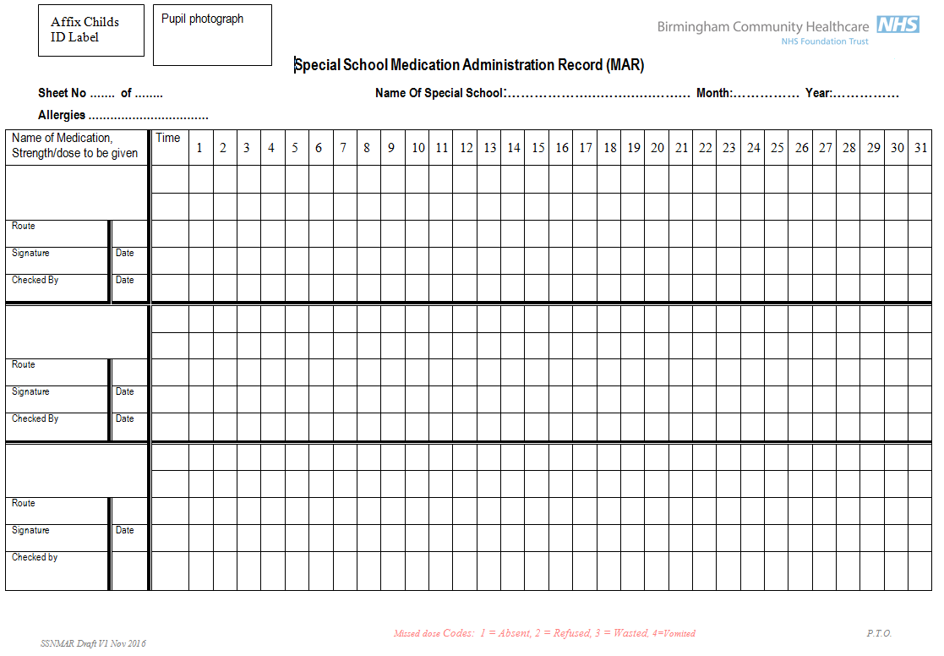

D1 – Asthma Plan

Primary version
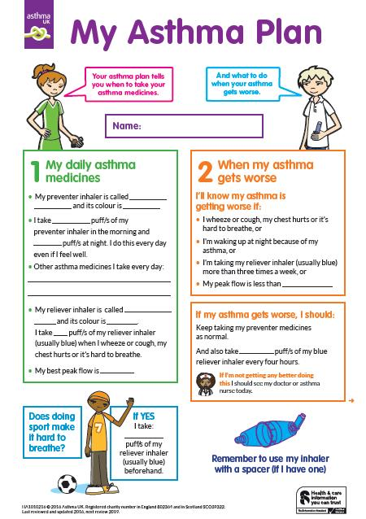 | 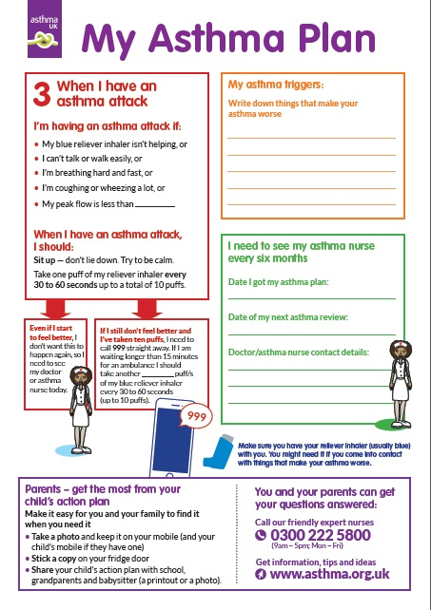
Secondary Version
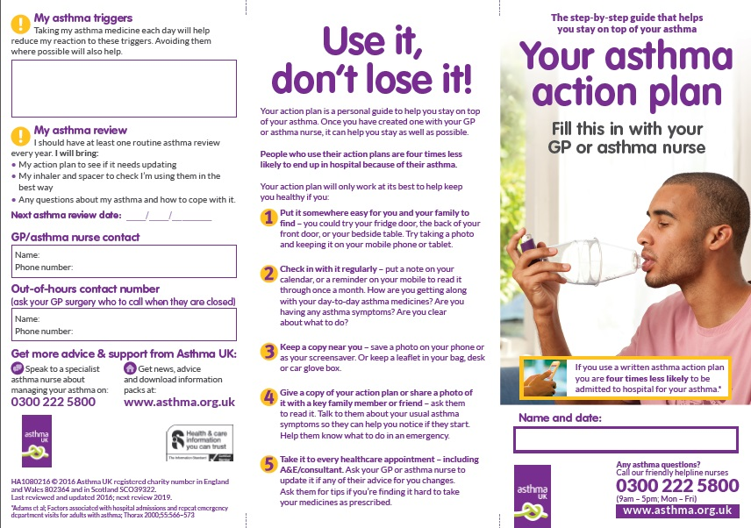 | 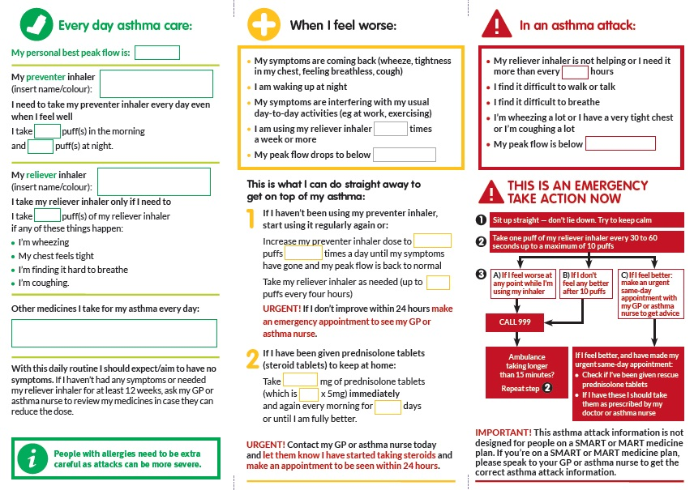

D2 – Anaphylaxis Healthcare plan

Jext Pen  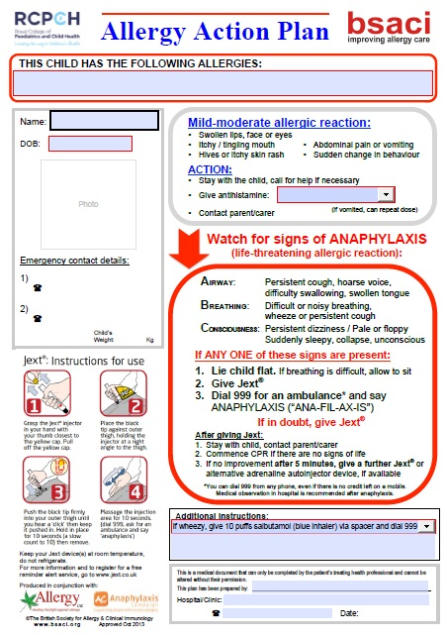 | Epipen  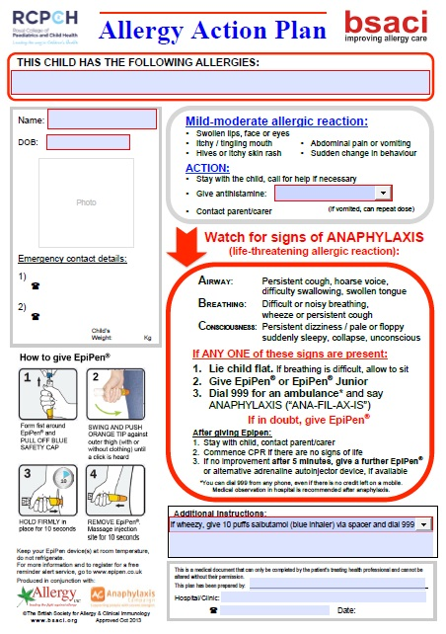
Emerade  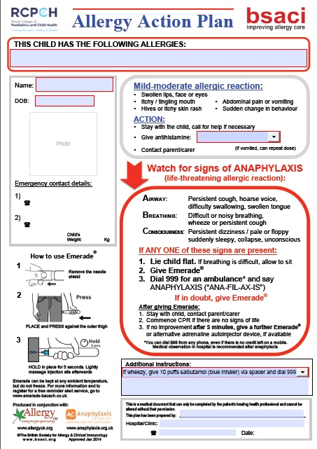 | Blank  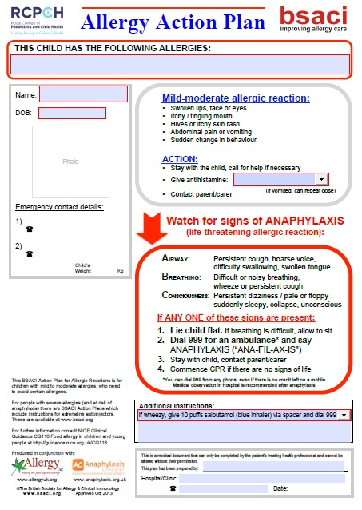

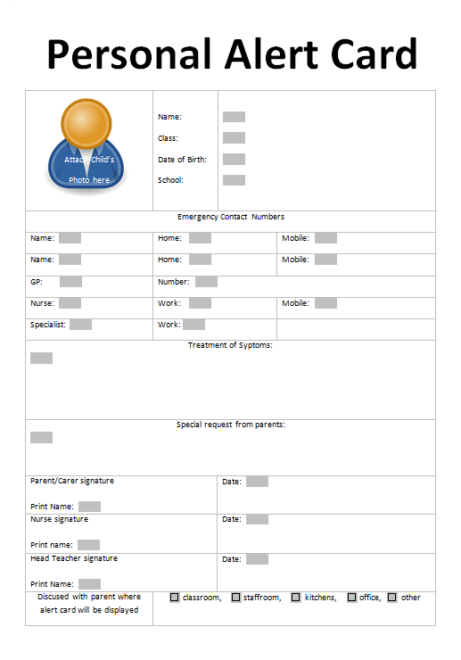
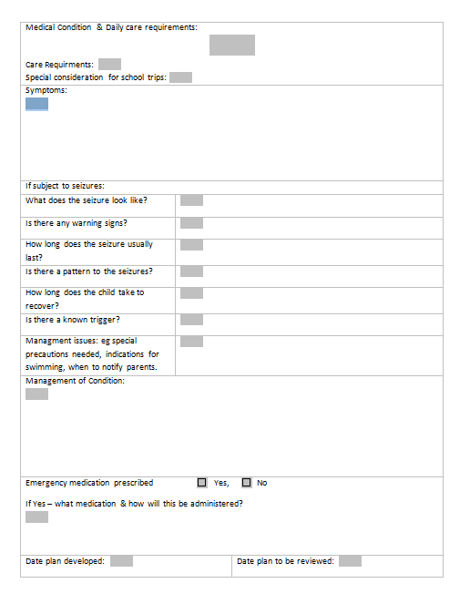
E. Example Sample letter
Address
Telephone contact details
Date
Dear parent/carer

Name of child – Medication in school

As you know, following consultation with you, your child, the school nurse or other healthcare professional and school staff, it has been agreed that your child requires, or may require, medicine to be administered to them during school hours. Your parental consent form and, if your child has one, their Care Plan, explains what medication needs to be administered and when.

It is parents’ responsibility to contact me, or another member of staff at the school, in order to check your child’s medication regularly, and at least on a termly basis, to ensure it is in date, there are no changes to the dose and it is still needed by your child. The medication should be replaced or removed as necessary, especially at the beginning of each new academic year.

If there are changes to your child’s condition and/or medication, please ensure the school and school nurse are notified as soon as possible.

I am available at the school/clinic, contact details as above, if you wish to discuss your child’s condition
Yours sincerely
School/School Nurse

F Example Training Record: staff training record – administration of medicines

Name of school/setting
Staff Name
Type of training received
Date of training completed
Training provided by
Profession and title

I confirm that the above named member of staff has received the training detailed above and is competent provide the treatment which was the subject of the training session outlined above.

Trainer’s signature

Date

I confirm that I have volunteered for and received the training detailed above.

Staff signature

Date

Review date

G Reviewing School’s Provision

Key questions | School’s Evidence
 | Achieved | In progress | Not achieved
- Do you ensure that parents and pupils are consulted about, and made aware of, your arrangements for supporting pupils with medical conditions in school?
- Do you promote pupils’ confidence and self-care in managing their own medical needs?
- Do you ensure that staff receive satisfactory training on supporting pupil’s medical needs in school?
- Do governors ensure that policies, plans, procedures and systems are properly prepared and implemented?
- Does the school have a policy for supporting children with medical conditions in school?
- Does the school have a contingency plan to cope if staff refuse to administer medication?
- Is the policy reviewed regularly?
- Is the policy easily accessible by parents & staff, in particular the section which explains the schools procedures for dealing with medication in school?
- Does a named individual have overall responsibility for implementation of the policy?
- Are arrangements in place to ensure that the policy is implemented effectively?
- Are Individual Healthcare Plans (IHPs) reviewed at least annually?
- Is there a named individual who is responsible for the development of IHPs?
- Is the school able to identify which staff in school need to be made aware of pupil’s medical needs and are those staff aware of which children have health needs and what support is required?
- Is written permission from parents and the head teacher obtained to allow administration of medication by a member of staff, or self-administration by the pupil, during school hours?
- Are arrangements identified in the policy to allow children to manage their own health needs?
- Do IHPs contain appropriate prescription and dispensing information?
- Are emergency contact details and contingency arrangements included within the IHP?
- Does the IHP explain what arrangements or procedures should be in place during school trips or other school activities outside of the normal school timetable so that the child can participate and are these reviewed prior to each event?
- Does practice reflect the policy?
- Does the policy identify roles and responsibilities?
- Are training needs regularly assessed?
- Have sufficient staff received suitable training?
- Is a record kept of training undertaken?
- Are written records kept of all medicines administered to children?
- Do all staff know what should happen in an emergency?
- Is the appropriate level of insurance in place and does it reflect the level of risk?
- Does the policy set out how complaints can be made?

